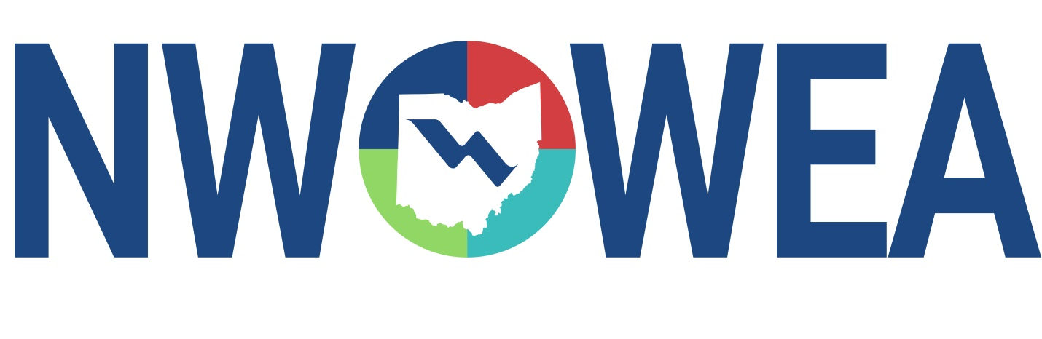

OWEA NW SECTION MEETING
August 19, 2020
Knights of Columbus Hall
111 Elliott Rd. Defiance, Ohio 43512

8:30-9:30 Registration (Donuts & Drinks)

9:30 – 9:45 Welcome and Introduction

9:45 – 10:45 Defiance WPCF Path to UV Disinfection

10:45 – 11:00 Break

11:00-12:00 Anaerobic Digester Upgrade

12:00 – 12:45 Lunch

12:45 – 1:00 Business Meeting & Election of Officers

1:00 – 2:00 Digester Rehabilitation Cost Saving Measures

2:00 – 2:15 Door Prizes

2:30 – 4:30 One-hour plant Tours at Defiance Wastewater Treatment Plant
26273 St. Rt. 281 East, Defiance OH 43512

Due to COVID-19 Social Distancing will be maintained during this seminar. Face Mask will be required.

The Northwest Section Would Like To Thank The Following Sustaining Sponsors;

Alloway Environmental Testing, Lima, OH
Baker and Associates, Carey, OH
BissNuss, Inc., Westlake, OH
Dmytryka Jacobs Engineers
Jones and Henry Engineers, Inc., Toledo, OH
Mosser Construction, Fremont, OH
MS Consultants, Inc. Columbus, OH
Peterson Construction Company
Smith Environmental, Columbus, OH
The Bergren Associates, Sylvania, OH
Waterworks Systems and Equipment, Inc., Lakeland, MI

